Question 1.

**Q1. A F&B manager wants to determine whether there is any significant difference in the diameter of the cutlet between two units. A randomly selected sample of cutlets was collected from both units and measured? Analyze the data and draw inferences at 5% significance level. Please state the assumptions and tests that you carried out to check validity of the assumptions.**

Business Problem: whether there is any significant difference in the diameter of the cutlet between two units?

Data collection:

Y1 = Unit.A

Y2 = Unit.B

**Two sample T test for equal variances**:

Null hyposthesis Ho: μ1 = μ2 (There is no difference in diameters of cutlets between two units)

Alternate hypothesis as Ha: μ1 ≠ μ2 (There is significant difference in diameters of cutlets between two units)

We can use 2 Sample 2 Tail test

Two Sample t-test data:

Inference:

As (p_value=0.4722) > (α = 0.05);

Accept Null Hypothesis

i.e. μ1 = μ2

Thus, there is no difference in diameters of cutlets between two units

There is no significant difference in the diameter of the cutlet between two units.

**Q2) A hospital wants to determine whether there is any difference in the average Turn Around Time (TAT) of reports of the laboratories on their preferred list. They collected a random sample and recorded TAT for reports of 4 laboratories. TAT is defined as sample collected to report dispatch.**

**Analyze the data and determine whether there is any difference in average TAT among the different laboratories at 5% significance level.**

Anova F test statistics: Analysis of varaince between more than 2 samples or columns

Ho : No Varaince: All samples TAT population means are same

Ha : It has Variance: Atleast one sample TAT population mean is different

Thus Alternate Hypothesis Ha as It has Variance: Atleast one sample TAT population mean is different   
Inference:

As (p-value=0) < (α = 0.05); Reject Null Hypothesis

i.e. Atleast one sample TAT population mean is different

Thus there is variance or difference in average Turn Around Time (TAT) of reports of the laboratories on their preferred list.

**Q3)**

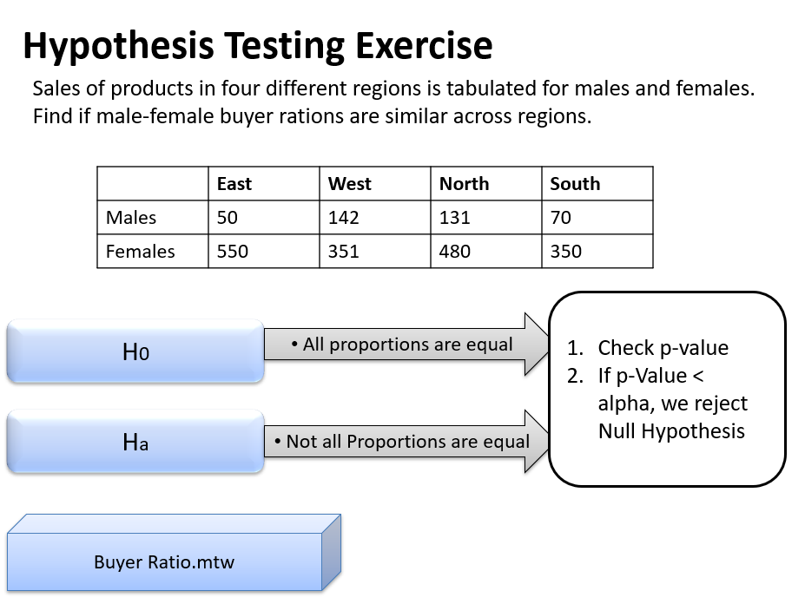

Ans) Ho: Independence of categorical variables (male-female buyer rations are similar across regions (does not vary and are not related)

Ha: Dependence of categorical variables (male-female buyer rations are NOT similar across regions (does vary and somewhat/significantly related)

**Chi2 contingency independence test**

(Chi2 stats value, p_value, df, expected observations)

Inference:

As (p-value = 0.6603) > (α = 0.05);

Accept the Null Hypothesis

i.e. Independence of categorical variables

Thus, male-female buyer rations are similar across regions and are not related

**Q4) TeleCall uses 4 centers around the globe to process customer order forms. They audit a certain % of the customer order forms. Any error in order form renders it defective and has to be reworked before processing. The manager wants to check whether the defective % varies by centre. Please analyze the data at 5% significance level and help the manager draw appropriate inferences**

Ans) Ho: Independence of categorical variables (customer order forms defective % does not varies by centre)

Ha: Dependence of categorical variables (customer order forms defective % varies by centre)

**Chi2 contingency independence test:**

Inference:

As (p_value = 0.2771) > (α = 0.05);

Accept Null Hypthesis

Thus, customer order forms defective % does not varies by centre